**Planning ,Scheduling and Estimation**

# Planning

* How to do the project
* dividing the project into a set of subtasks.
* Important part: **properly order them and avoid unnecessary dependency-related delay**

# Estimation

* An estimate is an informed guess, based on facts, about the amount of the resources( effort/time) that a task will require to complete.

# Scheduling

* Figuring out when to do the subtasks.

# Project Plan

# Statement of Work

# Resource List

# Work Breakdown Structure (WBS)

* + - It comprehensively lists all project activities required to complete the project.
    - The WBS needs to evolve as the project becomes better-defined and more details about required project.

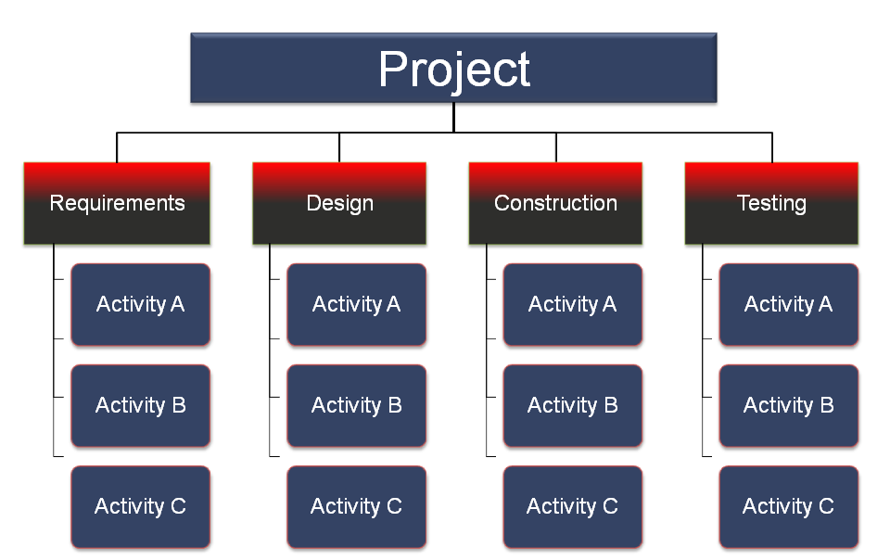

# Project Schedule

# Risk Plan

* + - Risk plan describes
      * Anticipated risks
      * Likelihood of their occurrence
      * How they might be handled
    - Example:

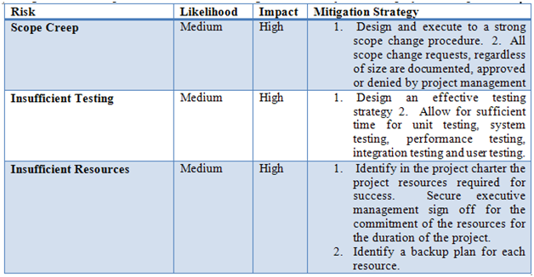

# Estimation Techniques *(estimate time required for each activity in a WBS)*

* 1. ***Wideband Delphi Process*** 
     1. ***Procedure*** 
        + *Choose a team and moderator*
        + *Hold a kickoff meeting to develop work breakdown strcutrue*
        + ***Hold an estimation session and achieve consensus***
        + *Assemble the final list of tasks and estimates*
        + *Review the results*
     2. ***Estimation session*** 
        + ***Start:*** 
          - *Team members share effort estimates for each task in the* ***work breakdown structure (WBS),*** *the moderator records these estimates and plots them on graph.*

**

* + - * ***Achieving consensus (Convergence):***
        + *Wideband Delphi process uses a number of rounds of discussion in the estimation session. In each round, team members discuss assumptions, clarify project details, and revise estimates.*

